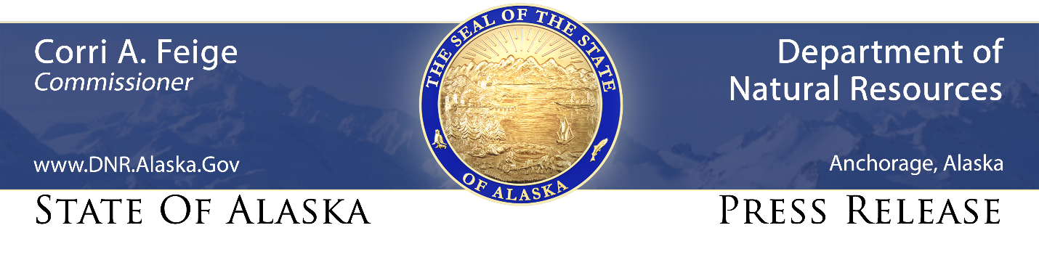
For Immediate Release: April 28, 2021

Celebrate Alaska Agriculture Day with great food and online prizes

(Palmer, AK) – With spring busting out all over, it’s time to join with the Alaska Division of Agriculture for online contests on Facebook and Instagram to celebrate delicious and healthy Alaska Grown food, and observe Alaska Agriculture Day on Tuesday, May 4.

For Facebook users, the division invites all Alaskans to participate by making a meal using all Alaska Grown foods, go to the Alaska Grown Facebook and post a photo and description of your dish as a comment on one of the Alaska Agriculture Day posts. Those posting earn the chance to win an Alaska Grown apron, plus a $25 Visa gift card.

Among the many farm-fresh Alaska Grown products currently available at fine retailers are: cucumbers, potatoes, fresh herbs, honey, birch syrup, barley flour, couscous, pancake mix, brownie mix, dairy, eggs, beef, chicken, and other meat products. If you don’t see them at your favorite store, be sure to ask for them.

Those who prefer Instagram – and might rather not cook – can look on Instagram for Alaska Agriculture Day posts, then Like, Follow, and tag three friends in the comments for the chance to win an Alaska Grown apron, plus a $25 Visa gift card.

The contests start today at 4 p.m., and end Tuesday at 11:59 pm. Winners will be announced Thursday at noon, simultaneously during the Division of Agriculture’s weekly Alaska Grown Facebook Live, as well as Live on the @alaskagrown Instagram account. Winners will also be notified through a direct message.

###

STAY CONNECTED:
DNR Newsroom: http://dnr.alaska.gov/commis/dnr_newsroom.htm
DNR on Social Media: http://dnr.alaska.gov/commis/social_media.htm
DNR Public Information Center: http://dnr.alaska.gov/commis/pic/

